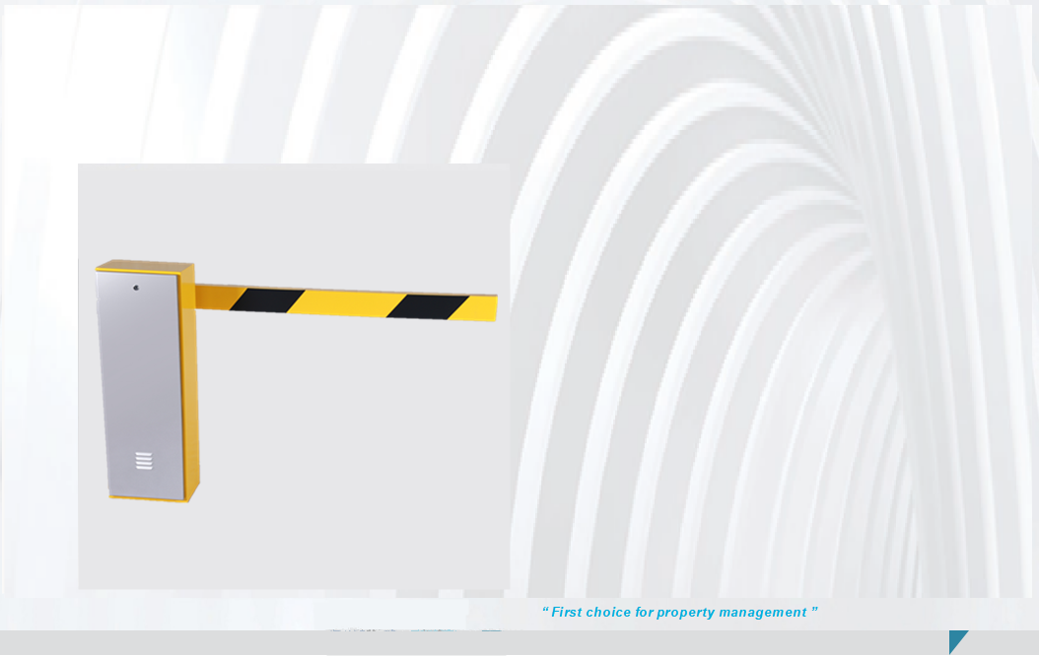
Smart Boom Barrier P628

First choice for property management
DC drive bushed motor--smoothly handle high-frequency use
Multiple boom types to meet different needs, especially for the property management.

Robust
High-strength carbon steel splicing frame--overall structure is solid and reliable
Brand-new spraying process: metal powder coating + UV-resistant cover -- enhance corrosion resistance and weather resistance
Integrated movement design-- gate runs stably and core components are resistant to wear

Safe & Reliable
Boom auto rebound protection--detect obstruction and boom rebound
Operation jam protection--the control system can automatically reduce the voltage and current to prevent the motor from being burned out.
Comprehensive anti-crushing protections: infrared anti crushing, radar anti crushing, digital anti crushing, loop detector for anti crushing
Adopt digital control technology -- protect gate operation in whole process, such as boom limit position protection, ambient temperature compensation protection, anti-blocking protection, illegal lifting alarm and record, etc.
Four Opening Methods
Gate boom opened by loop detector
Gate boom opened by remote control
Gate boom opened by motor (There is a knob on motor and only be used in emergency)

Specification
Model Name | P628
Power Supply | AC220±10％ AC110±10％
Operating Temperature | -30℃～80℃
Relative Humidity | ≤95%
Motor Power | 150W
Communication protocol | RS485 interface or ground detection protection device
IP Rating | IP68
Anti crushing | loop detector for anti crushing,  infrared anti crushing (optional), radar anti crushing (optional)
Anti Collision Boom | Support
Arm length | 3-6m
Dimension (L*W*H) | 340×245×970mm
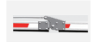

Straight Boom Folding Boom
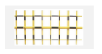

Telescopic Boom Three Column Fence

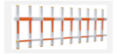
Two Bar Fence

Barrier Boom
Dimensions

Barrier Booms

Boom Type | Model name | Boom Length | Speed | Anti- collision | Boom Material | Anti-smashing Strip | Reflective Membrane
Straight Boom | P628 | 3≤L≤6m | 1-6s | Yes | Aluminum alloy | Optional | Yellow+black
Folding Boom | P628 | 3≤L≤6m | 1-6s | Yes | Aluminum alloy | Optional | Yellow+black
Telescopic rod | P628 | 3≤L≤6m | 1-6s | Yes | Aluminum alloy | Optional | Yellow+black
Three column fence | P628 | 3≤L≤6m | 1-6s | Yes | Aluminum alloy | Optional | Yellow+black
Two bar fence | P628 | 3≤L≤6m | 1-6s | Yes | Aluminum alloy | Optional | Yellow+black

Dimensions
